CALL FOR SUBMISSIONS:
Community engagement for inclusive rural transformation and gender equality
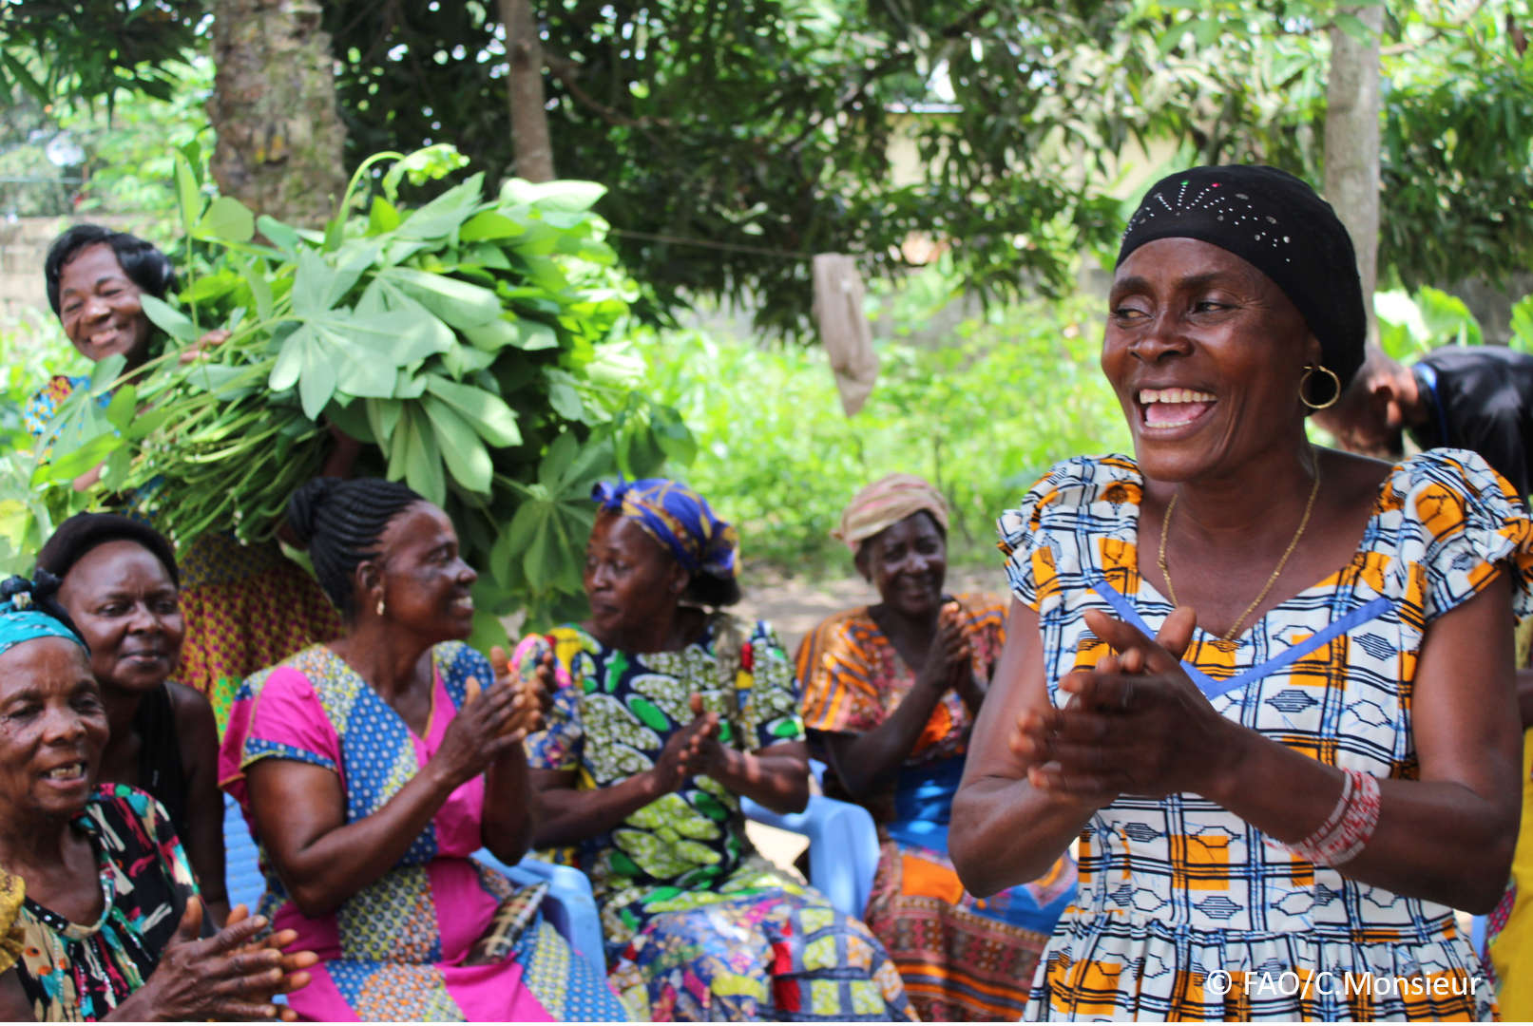
The objective of this call for submissions is to collect good practices, experiences, and lessons learnt on the use of community engagement for inclusive rural transformation and gender equality. The initiative, organized by the Rural Transformation and Gender Equality Division (ESP), seeks to gather insights from a diverse range of contributors, both within FAO and from external stakeholders. Its goal is to share knowledge, foster learning, and guide the scaling up of community engagement and community-led collective action to leave no one behind. The call builds on FAO's past efforts in this area, such as the Community Engagement Days series of webinars.
The call for submissions is open until 27 November 2024.

How to take part in this call for submissions:
To take part in this Call for submissions, please register to the FSN Forum, if you are not yet a member, or “sign in” to your account. Please review the topic note to understand the criteria we are considering for this call. If you wish to learn more about community engagement, you may refer to the background document. Once you have completed this submission template, upload it in the box “Post your contribution” on the call webpage, or, alternatively, send it to fsn-moderator@fao.org.
Please keep the length of submissions limited to 1,500 words and feel also free to attach relevant supporting materials.

Template for submissions

Contact person | Name: Aderaw Tsegaye, Adane Mengist and Baye Terefe  Organization/Unit: Ethiopian Institute of Agricultural Research, Debre markos Universiry  Country: Ethiopia  Email address: aderawtsegaye21@gmail.com, adanemengist@gmail.com,
Name/title of the good practice | Sustainable Watershed Rehabilitation Practices in Yegelaw Village, Amhara Region, North west Ethiopia.
Where is the good practice taking place? (Multiple selection allowed) | ☐ Europe and Central Asia  ☐ Latin America and the Caribbean  ☐ North Africa and Near East  ☒ Sub-Saharan Africa  ☐ Asia and the Pacific  ☐ North America  ☐ Global
Affiliation | ☐ Farmer and producer organizations  ☐ Trade Union  ☒ Informal community-based, farmer-based or self-help group  ☒ Research and academia  ☐ Government  ☐ Local/traditional authorities  ☐ Private Sector  ☐ Civil Society Organization  ☐ Intergovernmental Organization (e.g. UN system, World Bank)  ☐ Resource Partner/Donor  ☐ Other (please specify)
DEIn which sector(s) and context (s) have you used this community engagement good practice? (Multiple selections allowed) | ☐ Education  ☐ Health and Sanitation  ☒ Food production in agrifood systems (please also tick the sub-categories)  ☐ Crop cultivation  ☐ Fisheries and aquaculture production  ☒ Livestock  ☒ Forestry  ☐ Agroforestry  ☐ Horticulture  ☐ Apiculture (beekeeping)  ☐ Agroecology and sustainable farming practices  ☒ Soil and water management  ☐ Other: ____________  ☐ Post-production in agrifood systems (please also tick the sub-categories)  ☐ Processing and value addition  ☐ Marketing and retailing  ☐ Transporting  ☐ Food loss and waste  ☐ Packaging  ☐ Storage  ☐ Distribution  ☐ Other _________  ☐ Gender Equality  ☒ Climate Action  ☐ Citizenship and Governance  ☐ Social Protection  ☐ Humanitarian and protracted crisis  ☐ Conflict resolution, peace and resilience  ☐ Digital innovation  ☐ Other sector (please specify) _________
Who are the financial partners supporting this good practice, if applicable? | There is no financial support, but volunteer work is done through collaboration with the local community.
- In a few sentences, summarize your community engagement good practice.
The community engagement practice at Yegelaw village, facilitated by the Ethiopian Institute of Agricultural Research and Debre Markos University's community service program, exemplifies a successful model for addressing environmental challenges through collective action. Through participatory approaches, the local community, with institutional support, implemented targeted interventions such as constructing check dams, initiating afforestation programs, and adopting area closure techniques.
- What problem(s) or challenge(s) does your good practice aim to address through community engagement?
This community service project aimed to address challenges such as soil erosion, land degradation, and overgrazing, which threaten agricultural productivity and contribute to food insecurity. These issues were exacerbated by the lack of integrated watershed management and the impacts of climate change. Through community engagement, interventions such as check dams, afforestation, and area closures were implemented to restore the landscape, promote sustainable resource use, and enhance resilience.
- Describe your good practice in more detail. Include the main guiding principles, the desired changes or outcomes you aim to achieve (Theory of Change), and the key phases of implementation.

This community service project aimed to restore the ecosystem and improve land productivity in Yegelaw village, focusing on active community engagement and sustainability. The guiding principles included community ownership, collaboration, and the use of local knowledge. The desired outcomes were to reduce land degradation, improve soil fertility, and enhance agricultural productivity, ultimately contributing to better food security and resilience to environmental challenges.

The project was implemented in key phases:

A. Assessment and Planning: Evaluating land degradation and engaging the community.
B. Capacity Building: Training local people in sustainable land management practices.
C. Restoration: Implementing techniques like check dams and afforestation.
D.Monitoring: Tracking progress and making adjustments.
E. Empowerment: Ensuring community ownership of the restoration efforts.

- Who are the key actors and stakeholders involved in the design and implementation of the good practice, and what are their respective roles? Consider local partners, government, local authorities, community radios, civil society, research, the private sector, etc.
The key stakeholders involved in the Yegelaw community service project include:

- Ethiopian Institute of Agricultural Research (EIAR): Provided technical expertise and research support for land restoration.
- Debre Markos University: Contributed through academic support, research, and capacity-building activities.
- Yegelaw Community Association: Facilitated local participation, organized community members, and ensured the project addressed community needs.
- How does your intervention ensure inclusivity and equal and meaningful participation within the community?
Describe how your intervention includes and engages different groups within the community. Consider aspects like gender, age, ethnicity, disability status, livelihoods, and other specific conditions (e.g., people living in prolonged crisis, migrants, refugees). Explain how your intervention engages diverse segments of the rural community. Highlight the specific actions or strategies you use to reach these groups. If applicable, mention if your intervention uses specific approaches such as gender-responsive, gender-transformative, intersectionality, or other methods to ensure inclusivity and gender equality.
This community service project ensures inclusivity and equal participation by actively involving various groups within the community, with a focus on gender, age, and livelihood diversity. Specific actions for inclusivity include:
- Gender Sensitivity: The project ensures that both men and women participate equally, with a focus on empowering women through targeted training and decision-making roles.
- Age Inclusivity: The project incorporates youth and elders, leveraging the knowledge and energy of younger participants while valuing the experience and wisdom of the older community members.
- Livelihood Diversity: The project accommodates different livelihood backgrounds, such as farmers and pastoralists, ensuring that all community members are involved in the planning and implementation processes.
- Disability Consideration: Accessibility for people with disabilities is ensured through adapted training materials and field activities that cater to their needs.

- By using community engagement, what results and impacts have your good practice achieved?
Please provide specific examples and evidence demonstrating the effectiveness of your intervention, focusing on both qualitative and quantitative outcomes related to livelihoods and well-being improvements.

The community engagement project in Yegelaw village achieved significant impacts, including restoring degraded land through afforestation, soil conservation, and area closures, which improved agricultural productivity and water retention. Approximately 750 households benefited, with over 200 hectares of land reclaimed, enhancing food security and livestock management. The participatory approach empowered the community, strengthened local collaboration, and promoted sustainable practices, fostering environmental restoration and social cohesion.
- Among these results, has the good practice led to improvements in terms of gender equality, women’s empowerment, and/or social inclusion?
Describe the behavioral changes in terms of gender that the good practice promotes, emphasizing agency, leadership, and participation in local governance. Include efforts to challenge discriminatory norms and unequal power dynamics. Highlight also how the intervention has supported the well-being (including psychological resilience) of marginalized groups and enhanced their inclusion and participation in decision-making processes.

The community engagement project in Yegelaw village has promoted gender equality and women’s empowerment by encouraging women’s active participation in planning and decision-making processes. Women played key roles in restoration activities, gaining leadership opportunities and contributing to local governance. The project also fostered social inclusion by involving marginalized groups in resource management, enhancing their psychological resilience, and challenging traditional norms that previously limited their participation.

- What key challenges did you encounter while implementing the community engagement activities, and how did you address them?
Include any resistance from communities, pushback, or issues related to unequal power dynamics, if applicable.
Key challenges encountered during the implementation of community engagement activities in Yegelaw village included initial resistance from the community, primarily due to a lack of awareness about the long-term benefits of watershed rehabilitation. Unequal power dynamics also emerged, with certain groups dominating decision-making processes, limiting the participation of marginalized members. Additionally, logistical constraints, such as resource shortages and coordination issues among stakeholders, hindered smooth implementation. These challenges were gradually mitigated through persistent awareness campaigns, inclusive decision-making frameworks, and strengthened partnerships with institutions like the Ethiopian Institute of Agricultural Research, Debre Markos University, and Yegelaw Community Association.
- What are the key lesson learned from your community engagement good practice?
Key lessons learned from the community engagement project in Yegelaw village include the importance of early and consistent community sensitization to ensure buy-in and participation. Establishing inclusive decision-making structures fosters equitable involvement of all community members, particularly marginalized groups. Collaborative partnerships with institutions were critical for resource mobilization and technical support. Additionally, integrating local knowledge with scientific approaches strengthened the effectiveness of interventions and enhanced community ownership. Flexibility and adaptability in addressing challenges, such as resistance and logistical issues, also emerged as vital for achieving sustainable outcomes.

- Has this practice been replicated in the same context or in different contexts?
What are the required conditions to replicate and adapt the practice in another context/geographical area?
While this community engagement practice has primarily been implemented in Yegelaw village, its core principles and strategies hold promise for application in similar contexts. Its success highlights the potential for adaptation in other ecological and socio-economic settings, such as areas facing land degradation and watershed challenges in Ethiopia. For replication, the practice would require key enabling conditions, including community readiness, institutional support, technical expertise, and resource availability. Ensuring alignment with local needs and conditions, as well as fostering partnerships with stakeholders like research institutions and community associations, is crucial for successful adaptation in new areas.

- How sustainable are the results achieved by this good practice?
Describe the key elements that need to be in place to make the initiative sustainable, including enabling environment (legal and policy frameworks and institutions), local ownership, accountability, etc.
The sustainability of this project relies on local ownership through the Yegelaw Community Association, strong institutional support from research and academic partners, and an enabling policy environment. Accountability through monitoring and community capacity building ensures long-term maintenance of the rehabilitated watershed and integration into broader development plans.
- Based on the conversations FAO held during the Community Engagement days, a definition of community engagement for empowerment was proposed:

“Community engagement for empowerment and community-led collective action can be defined as an inclusive and participatory process that enables community members to become active agents of change in decisions affecting their lives, health, and environment. This process develops their capacity to achieve sustainable outcomes for improved rural livelihoods. Embracing a rights-based approach, it prioritizes the agency and participation of all community members, regardless of gender identity, sexual orientation, age, ethnicity, caste, socioeconomic status, political affiliation, migration status, or ability/disability. Indeed, inclusive approaches recognize the complexities of overlapping marginalization and discrimination that can exclude different community members from decision-making processes and implement strategies to foster their participation, agency and empowerment.”

We invite you to contribute to this definition. What would you add or change? Please share your thoughts, suggestions, and any additional elements you believe are crucial for a comprehensive understanding of community engagement approaches aimed at community-led collective action for inclusive rural transformation, people’s empowerment and gender equality.
The definition of community engagement for empowerment is strong, but could be enhanced by emphasizing the importance of trust-building and long-term relationships between stakeholders for sustainable outcomes. It should also highlight the value of local knowledge systems and capacity-building at all levels, as well as inter-generational collaboration to integrate diverse perspectives. Lastly, the inclusion of accountability mechanisms ensures that marginalized groups are heard and their rights respected in decision-making. This would strengthen the focus on empowerment, inclusive transformation, and gender equality.
- Based on your experience, what gaps or areas for improvement still need to be addressed in the field of community engagement?
Key gaps in community engagement include:

- Sustaining Participation: Maintaining long-term community involvement beyond initial phases.
- Incorporating Local Knowledge: Integrating local insights into decision-making for more relevant solutions.
- Accountability Mechanisms: Ensuring clear structures for accountability to enhance trust and transparency.
- Gender and Power Dynamics: Addressing persistent power imbalances that hinder full participation of women and marginalized groups.
- Resource Availability: Overcoming limitations in financial and human resources to scale and sustain projects.
Addressing these areas will improve the impact and longevity of community engagement initiatives.
- What do you think is FAO's role in the field of community engagement? How can FAO support and enhance interventions like yours, if applicable? Consider aspects such as policy advocacy, capacity development, funding, technical assistance, knowledge production and sharing, and fostering partnerships.
I prefer FAO to provide capacity-building opportunities, such as training local communities and institutions in sustainable land management practices and watershed restoration techniques. Funding from FAO could be crucial to further develop and implement my research, especially regarding community-driven initiatives for watershed rehabilitation. Additionally, I would welcome FAO's technical assistance in refining my approach and applying best practices in community engagement and environmental restoration. Knowledge sharing through FAO's global networks would be valuable for disseminating findings and learning from similar projects.
Link(s) to specific references about your good practice (e.g. reports, communication products, videos, articles) | Please include attachment(s) or add here link(s) to documents/videos/podcasts/other with specific references.  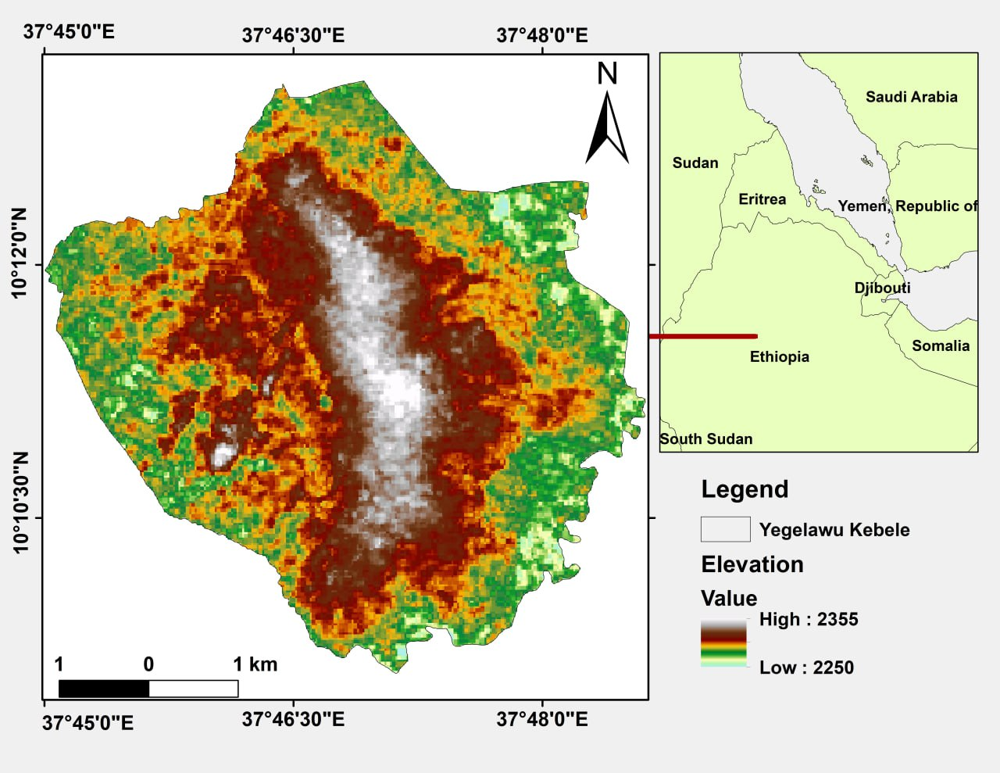  Figure1: Locational map of the project  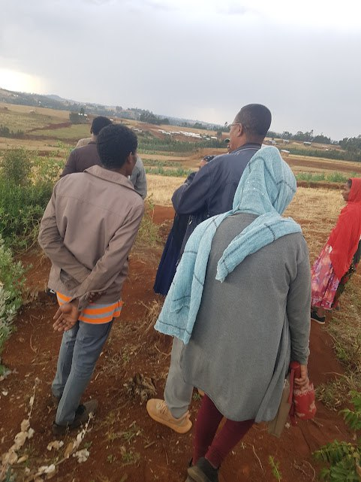  Figure 2. Community leaders during field visit pre_rehabilitation work at Yegelaw Village.  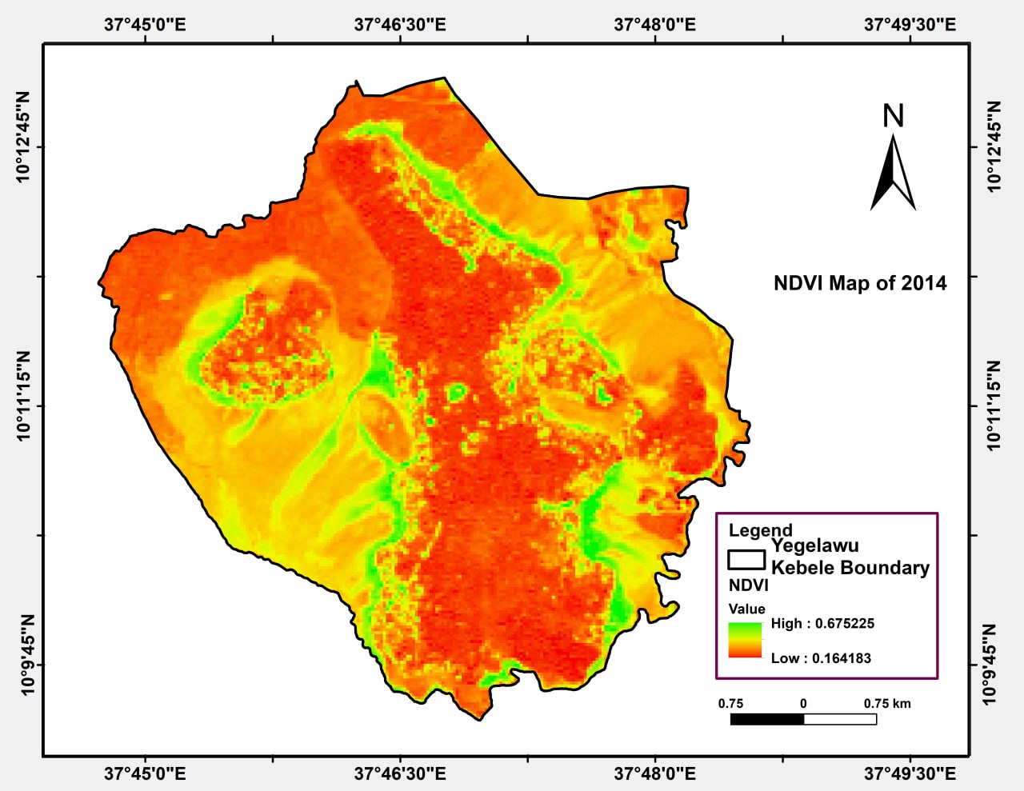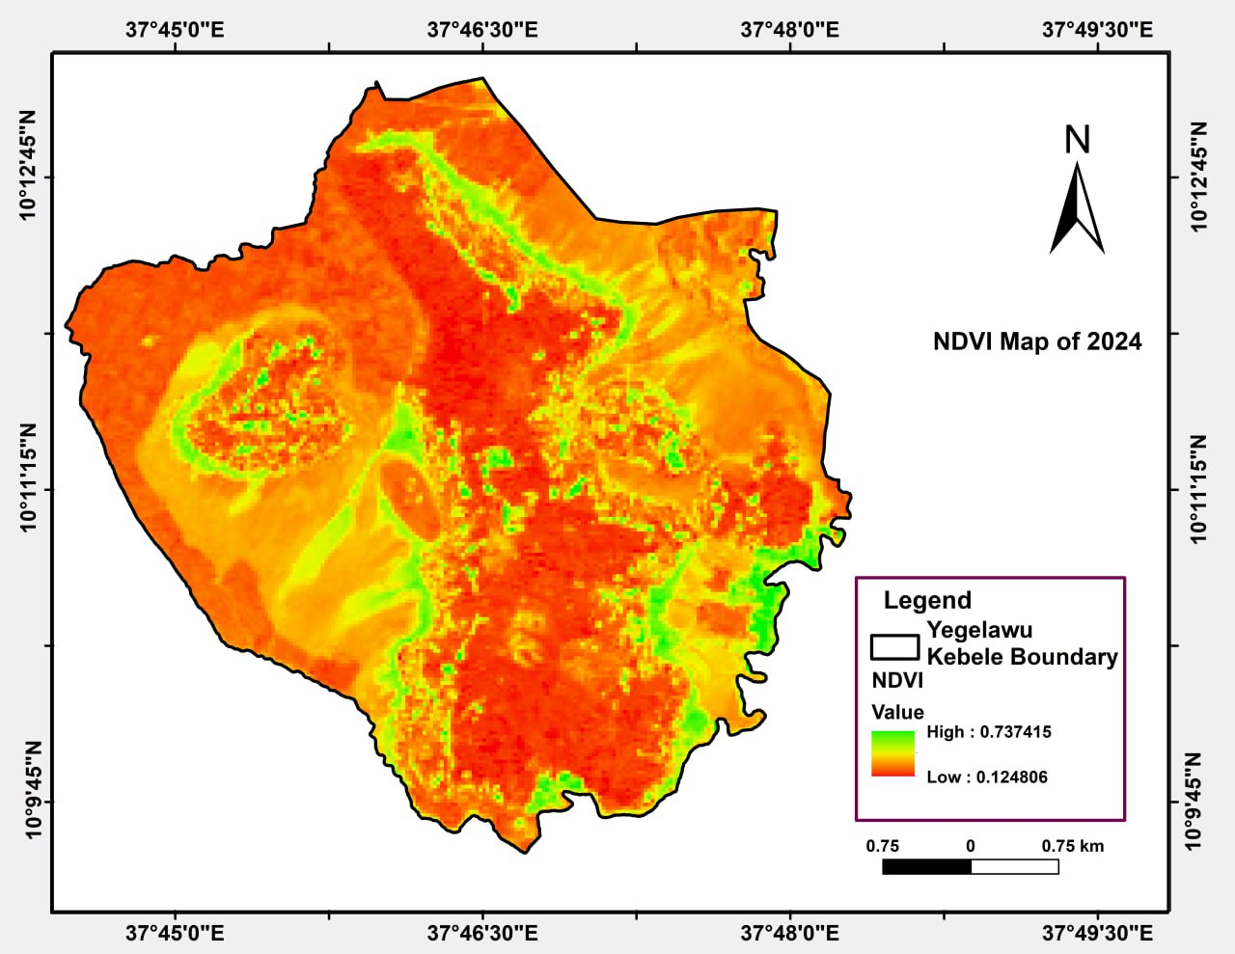  Figure 3. Pre and post rehabilitation Map (NDVI) of the study area.

The call for submissions is directly aligned with the thematic components of collective action within FAO's Programme Priority Areas (PPAs), specifically Better Life 1 (Gender Equality and Rural Women’s Empowerment), Better Life 2 (Inclusive Rural Transformation) and Better Life 3 (Agriculture and Food Emergencies).

